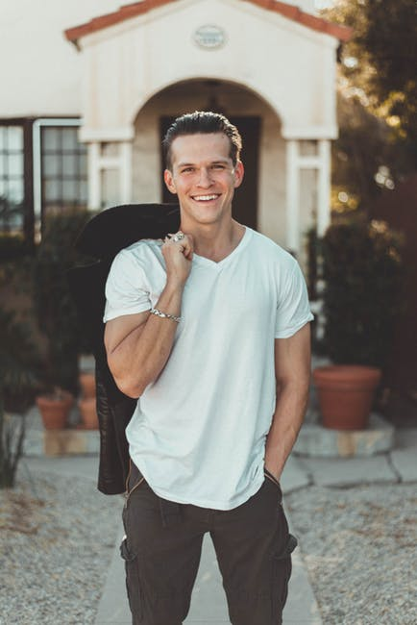

Hi, my name is Olly, and I am the Fundraising and Accounts Coordinator. I organise all of the money we have been donated and organise fundraising events so we can get enough money to help pay for the vaccinations, food and basic running cost of our business. I am 24 years old and only moved to Invercargill from New York 2 years ago, where I studied in a 4 year accounting course. In my spare time I really enjoy participating in triathlon events and also reading a good book.

**Olly Manning**

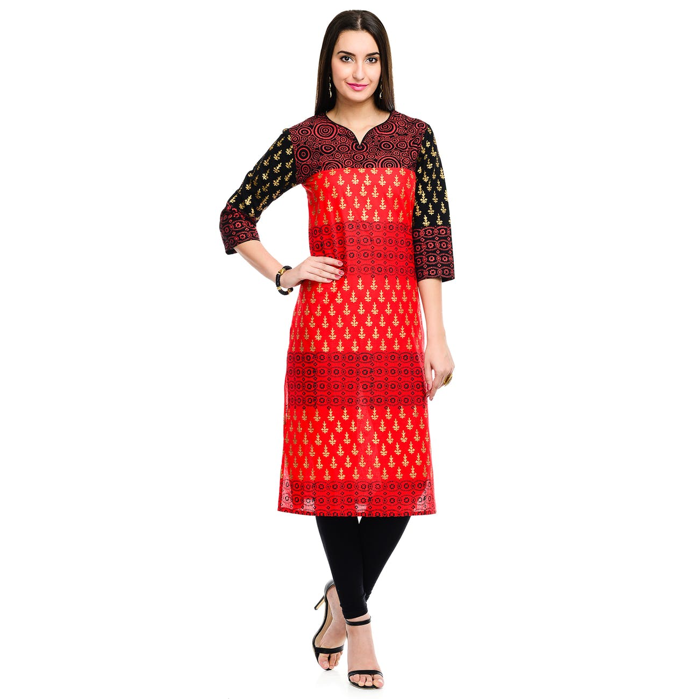

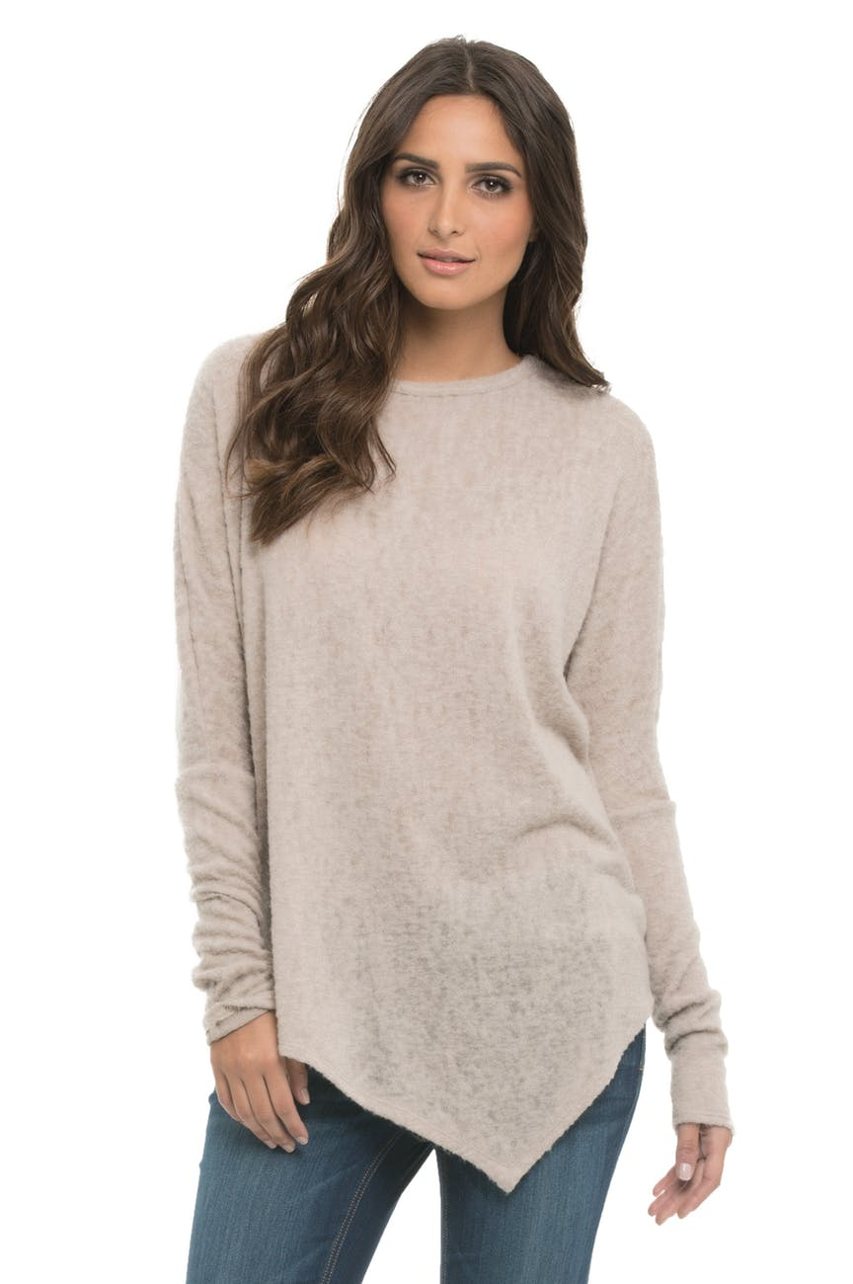

Hey! I’m Natalia and help organise all of our wonderful young volunteers that help us out here at PAWS. I help train each individual on what they need to do to help out the animals. I also promote and advertise around high schools and in local shop windows to try and get as many volunteers as possible. I am 20 years old and apart from working here at PAWS, I am studying Business at SIT. I have always loved animals and I grew up on a farm that had a wide variety of animals; Horses, Sheep, Cows, Chickens, Dogs, Cats and 3 pet Fish. In my spare time I love baking and donating it to the local food banks and hospice.

**Natalia Austin**

**Nadiene Hughes**

Hello, my name is Nadiene, and I am the Secretary here at PAWS. I help keep everything on track and sort out all through the paper work. I can answer any question’s anyone has about adopting or volunteering to help. I am 30 years old and have 2 daughters, Elly and Sabrina. We have 3 Cats and a Hamster at home too! I my spare time I enjoy braiding hair and swimming. I also enjoy making dresses for my two girls too.

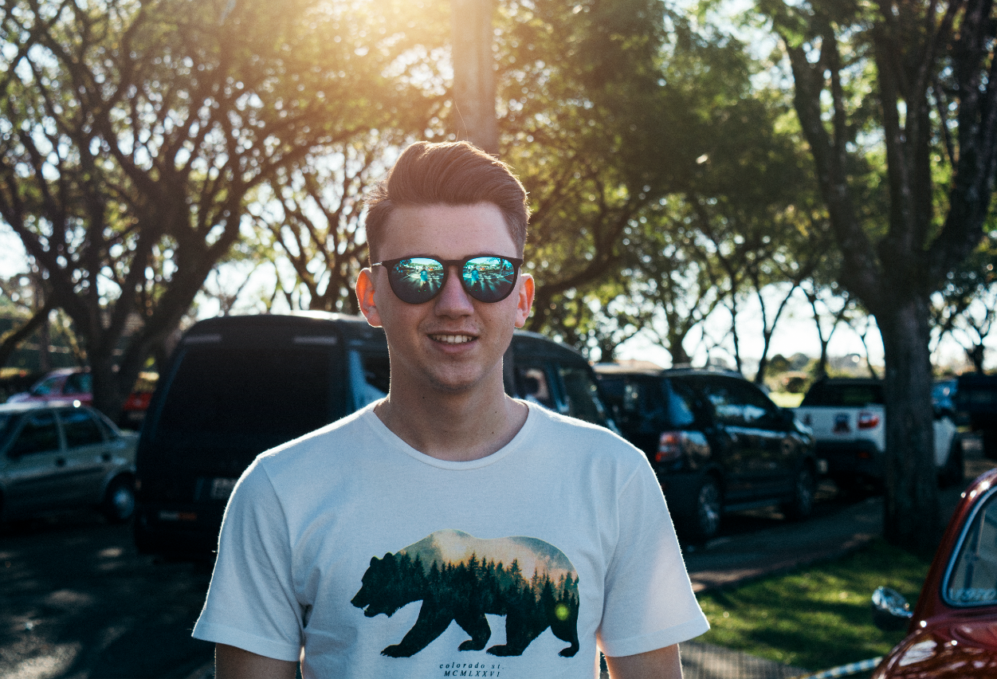

Kia Ora, My name’s Sara and I am the CEO and Head Manager at PAWS. I help make sure our business is doing the best it can possibly do for the animals that are in our care, and I also make sure we run the business smoothly and lead our team to success. I am 39 years old and I have a son called Alex and twin girls, Rachel and Paige. I love exercising and working out both with my dogs and my family. I have always loved being a leader and have wanted to be “The Boss“ of a business ever since I was young. I am lucky enough to be able to do that whilst working alongside a great team and also being able to care and nurture for the animals.

**Sara Reid**

Hi! My name’s Jack and I am the local Veterinary Physician at PAWS. I help make sure all of our animals are up to scratch with their health and wellbeing and making sure they have a clean bill of health when it comes to being adopted. I have a Golden Yorkshire Terrier Puppy called Alfie and a Pufferfish called Neve. I am 27 years old and in my spare time I like playing cards and baking muffins for my friends at work.

**Jack Freeman**